Background
Current trends and recent developments in phylogenetic codon substitution models
Thibault Latrille
Master BioSciences, Département de Biologie, Ecole Normale Supérieure de Lyon.
UMR CNRS 5558 Laboratoire de Biométrie et Biologie Évolutive (LBBE)
2017-12
Keywords : codon substitution models; synonymous/non-synonymous substitution; positive/adaptative selection; negative/purifying selection; phylogeny;
For protein-coding DNA sequences, reconstruction of phylogenetic trees crucially depends on whether substitutions are modeled at the nucleotide or the amino-acid level. Each level fails to account either for selection or mutation. Modeling at the level of codons can account for both mutation and selection, and one can detect and quantify protein adaptation as a deviation from the null hypothesis. This review of codon substitutions models focuses on two contrasting views of the null hypothesis. In the neutral hypothesis, the probability of fixation of non-synonymous mutations is fixed, while it can vary in the nearly-neutral hypothesis. Nearly-neutral codon models are more complex, are computationally more intensive but are more sensitive to detect protein adaptation.
Phylogenetic reconstruction seeks to infer past evolutionary history of life on Earth. However, phylogeneticists are constrained to solely access present-day populations and extinct fossils. One approach to circumvent this limitation is to study the evolution of molecular sequences backward in time, based on present day molecular sequences. In this molecular framework, evolution is generally seen as a stochastic process, and the interplay between point mutations and the selection of these mutations leads to substitutions in sequences over time [1]. Thus, molecular evolutionary biologists design substitution models of the sequences, and compute how likely they would observe the present-day molecular sequences, given a past-history scenario and a model of substitutions [2,3].
One major assumption of substitution models is independence between sites, meaning that any position of the sequence has its own independent evolutionary process and a substitution at one position does not affect the substitution process at other positions. The motivation for this assumption is rooted in computational complexity rather than biological meaning, and crucially constrains the modeling process [4].
Under the site-independence assumption, the modeling approach essentially depends on the nature of the sequence under study. For example, non-coding DNA sequences are subject to very different evolutionary forces compared to protein coding DNA sequences, and must be addressed differently. This review will focus on substitution models designed to address solely protein coding DNA sequences. In such coding DNA sequences the mutation process occurs at the DNA level, but selection process occurs at the protein level in first approximation. Thus studying protein coding DNA sequences at the nucleotide level has a major shortcoming of not taking into account the true underlying selection process, which can lead to false conclusions in the phylogenetic reconstruction. One simple approach to resolve this conflict is to study the evolutionary history of the protein instead of the DNA sequence, meaning translating nucleotide sequences into amino-acid sequences, and design a model at the amino-acid level [5]. Equally, amino-acid substitution models have also the major shortcoming of not taking into account that the mutation process occurs at the nucleotide level. Indeed, when studying sequences at the amino-acid level, the degeneracy of the genetic code leads to loss of information present in the mutated DNA sequences, since the 61 codons are converted to the 20 amino-acids.
For protein coding sequences, both DNA and amino-acid substitution models fail to take into account either the selection or the mutation process. These shortcomings are both addressed by codon models, basically combining the best of both models by studying nucleotides in triplets instead of independently. In a codon substitution model, a mutation of a nucleotide in a triplet will either be synonymous, meaning not changing the translated amino-acid, or non-synonymous, meaning the translated amino-acid will be different (see figure 1). Codon substitution models can estimate explicitly the ratio of the non-synonymous over the synonymous substitution rates, denoted ω [6,7]. Moreover, assuming there is no selection acting on synonymous mutation, ω is absorbing the signal of an excess in the rate of non-synonymous substitution, leading to ω>1 and meaning the protein is under adaptive selection. On the opposite, a default of non-synonymous substitution, leading to ω<1, means that the protein is under purifying selection.
The seemingly flaw of the degeneracy of the genetic code is in fact an advantage when one devises a model at the codon level in DNA sequences. One can identify the interplay between mutations acting at the DNA level, and positive or negative selection acting at the protein level. Thus, codon substitution models are crucial for a better modeling of the underlying evolution of protein coding DNA sequences, and consequently allow a better reconstruction of phylogenies. In this review, we will study different codon substitution models, based on different assumption made on the underlying evolutionary process. First we will review so called models based on the neutral hypothesis, corresponding to the original codon substitution models. Secondly, we will review models based on nearly-neutral hypothesis, explicitly including the purifying selection as a null hypothesis. And finally, we will review methods for models comparison and selection, and the limit of this review.

Detecting deviation from neutrality
The first codon substitution models, derived separately by Muse and Gaut [6] and Goldman and Yang [7], both in 1994, estimate a single parameter ω, namely the ratio of the non-synonymous over the synonymous substitution rates, capturing any deviation from neutrality over the entire sequence and along all branches of the phylogenetic tree (see box 2). The parameter ω, estimated by maximum likelihood (see box 1), is statistically tested against the null hypothesis of neutrality (ω=1).
Despite of the success of the original codon model as the first DNA sequence evolution model allowing for detection of protein adaptation, it has two shortcomings. A first mathematical shortcoming is that even if one does not get a statistical departure from neutrality (ω=1), it could be due to a mixture of both adaptive and purifying processes that cannot be untied since ω is a global parameter over the entire sequence. A second shortcoming of the method, rooted in biological principle, is that positive selection often operates against a background of strong negative selection. Indeed mutations that disrupt the protein conformation or any biological requirements are strongly selected against. As a result of basal purifying selection, the overall ω of a sequence is typically greatly below 1, even in the presence of an adaptive process. The consequence is that evolutionary biologists focused their efforts on detecting the presence of adaptive selection (ω>1), since detecting an ω lower than 1 was biologically expected for any protein.
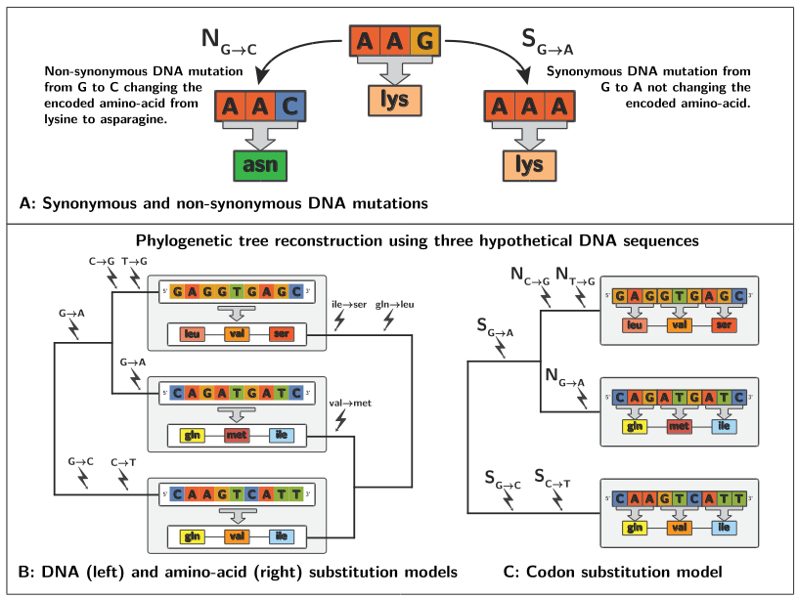
Figure 1. A mutation of a nucleotide in a triplet will either be synonymous or non-synonymous (panel A). Thus, by modeling sequences substitution at the nucleotide level (panel B, left side), one fails to account that the selection occurs at the amino-acid level. But by modeling the substitution at the amino-acid level (panel B, right side), one fails to account that mutations occurs at the nucleotide level and can be synonymous. Instead, by modeling at the codon level, by triplet of nucleotides, codon models can account for both mutation and selection (panel C).
Acknowledging the flaws of the initial codon models, it has been rapidly recognized that the parameter ω should not be estimated globally over the entire sequence [8]. The codons need to be separated into a finite number of different categories, with each category having its own ω. In such called sites models, the number of categories is specified before the analysis, and the category each codon falls into is estimated by maximum likelihood in so called finite mixture model (see box 1) [8–10]. In finite mixture models, the number of categories that increases the goodness of fit of the model can be asserted by the use of Akaike Information Criterion (AIC, see box 1). Using AIC, the computations usually estimate a number of categories tending to infinite, ultimately suggesting that each codon of the sequence should have its own ω [11]. In the Bayesian framework (see box 1), in contrast to maximum likelihood, the number of categories can be a variable. The flexibility of the computation mainly done by Markov Chain Monte Carlo (MCMC, see box 1) allows one to draw ω from an infinite mixture, usually using a Dirichlet process (see box 1), giving a posterior distribution of the parameter ω [12,13].
Beside a site refinement, a time refinement of the initial methods has been studied [14]. The motivation was to allow for the parameter ω to be estimated only on a subset of the phylogeny, based on biological assumption. For example, such models can detect an adaptive process ongoing during the divergence of one lineage, this can allow for the detection of the proteins responsible for speciation.
Naturally, both these space (site models) and time (branch model) refinements mentioned above where combined in so called branch-site models [15–18]. The fine-grained tunning of site-branch models increased statistical power by seeking short and strong episodes (time component) of adaptive selection on a background of purifying selection (site component). However, in the case of Red-Queen processes (see box 1) ongoing on the protein, the episodes detected by branch-site models would merely be a small fraction of the underlying adaptation. Indeed, the overall tree is under an adaptive process and one cannot contrast a branch to the rest of the tree.
Box 2. Mathematical definitions of the substitution codon models.
Mathematically, the lack of sensitivity of models seeking deviation from neutrality can be tracked to the assumption that the substitution rate is the same for any non-synonymous change (see box 2) [11]. This assumption of equal amino-acid preference means that the probability of reaching fixation is the same for any non-synonymous mutation, regardless of the original and mutated amino-acid encoded by the codon. This is a very strong assumption for studying evolution of protein-coding sequences.
Contrasting to models based on neutral hypothesis, codon substitution models reviewed in the next paragraph relax the assumption of neutrality by introducing different amino-acid preferences.

Detecting deviation from near-neutrality
Substitution in a sequence is the result of the interplay between mutations and selection. More precisely the rate of substitution is equal to the rate of mutation multiplied by the probability of fixation of the mutation [1]. Crucially, the probability of fixation depends on the difference of fitness between the mutated sequence and the original sequence [19,20]. In mutation-selection codon models, the probability of reaching fixation is different for any non-synonymous mutation. More specifically, it will depend on the original amino-acid preference and the mutated amino-acid preference encoded by the codon (see figure 2). From a dynamical perspective, a mutation on a codon with high preference (of the encoded amino-acid) will have a low probability of fixation, since the mutated codon will have a lower preference, and thus at equilibrium, this low probability of fixation of the codon is compensated by an high frequency of the codon. Essentially, at equilibrium the codon frequencies only fluctuate at the mutation-selection balance, and all the mutations are neutral on average, but slightly deleterious or advantageous, hence the name nearly-neutral models [21–23].
For evolutionary biologists, the assumption of equal amino-acid preference is equivalent to have a flat fitness landscape for all amino-acids, with neither a peak nor a valley. In contrast, in nearly-neutral models, the amino-acids have a fitness landscape fixed in time, but that is not flat. The difficulty and complexity of nearly-neutral models is to estimate the underlying amino-acid fitness landscape [24]. Moreover, nearly-neutral models consider multiplicative fitness across-sites.
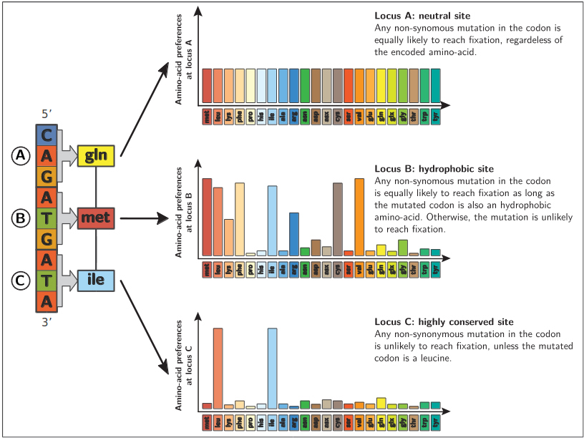
Figure 2: Under the nearly-neutral hypothesis, each site in the codon sequence has its own independent codon preferences. For any non-synonymous mutation, the probability of reaching fixation is determined by the ratio between the amino-acid preference of the mutated codon, and the amino-acid preference of the original codon.
Nearly-neutral models display the important feature of genuinely accounting for purifying selection. Indeed Spielman and Wilke showed mathematically in 2015 [25] that if the underlying process is nearly-neutral substitution, the ω estimated by the model seeking deviation from neutrality will always be lower than 1 (whatever the codon preferences). In other words, if one use a codon substitution model based on the neutral hypothesis but the actual process is nearly-neutral, it will be interpreted as purifying selection (ω<1). Notably, if only one amino-acid has a very high preference when all they others have a low preference, the estimated ω will tend to 0.
A first approximation of nearly-neutral models is that all the positions of the sequence share the same amino-acid preferences. But it has been rapidly recognized that each site in the codon sequence should have its own independent codon preferences (see figure 2) . Site-specific amino-acid preferences have been estimated either by maximum likelihood [26,27], by experimental means [28], or in a Bayesian context have been estimated using non-parametric prior distribution with Dirichlet process [29,30].
Once the amino-acid preferences are estimated, the nearly-neutral model is set, and one can estimate the deviation from near-neutrality with the parameter ω* [23,28]. As in all codon models, ω* is the ratio of the non-synonymous over the synonymous substitution rates, but the non-synonymous substitution rate is weighted by the probability fixation induced by the amino-acid preferences (see box 2) [23,28]. Specifically, protein adaptation would require to produce a ω>1 to be detected, which only concern very strong adaptation, but would be detected as long as they produce a ω*>1. However, the nearly-neutral assumption can be broken in two ways.
First, the nearly-neutral assumption can be broken if amino-acids have time-dependent preferences. This phenomenon is known as a Red-Queen process. In this case, by definition, the protein sequence is tracking a constantly moving fitness optimum. Since the protein sequence is always lagging behind the moving target defined by the amino acid preferences, and since substitutions are accepted preferentially if they are in the direction of this target, substitutions are on average adaptive. Thus breaking the assumption of time independence of amino-acid preferences leads to ω*>1 [23].
Second, the nearly-neutral assumption can also be broken if there is no independence between sites. This phenomenon is known as epistasis between sites. Unfortunately, one consequence of epistatic interactions is that even if a mutation is nearly-neutral upon fixation, subsequently fixed mutations on other sites make the original substitution more and more deleterious to revert over time [31–33]. This effect relies on a dependence of subsequent substitutions on the firstly fixed one. Thus, breaking the assumption of independence between sites leads to ω*<1 [23].
To summarize, a departure from near-neutrality with a ω*>1 is a signature of an ongoing Red-Queen process and that the protein is under ever changing adaptation. On the other hand, a ω*<1 is a signature of epistatic interaction between amino-acids. But one shortcoming of nearly-neutral codon substitution models is that if one does not get a statistical departure from near-neutrality (ω*=1), it could be due to a mixture of both Red-Queen and epistatic processes that cannot be untied.

Models comparison and selection
We saw that various codon substitution models can be used to detect and quantify positive and negative selection in protein coding sequences, as a deviation from neutrality or from near-neutrality. As such these models must be compared rigorously, in order to enable the selection of the more adapted model, based on mathematical rational and goodness of fit of the model to the data. It is also necessary to make sure that the assumptions made by these models are not broken. But beside the detection and quantification of protein adaptation, codon substitution models are used to construct phylogenies. Thus it is crucial to select models that correctly reproduce the underlying evolutionary process, otherwise the reconstructed trees will be meaningless and more dramatically will lead to false conclusions. Model comparison and selection can be studied in both Maximum likelihood and Bayesian contexts (see box 1).
In a Maximum likelihood framework, the simplest case of model selection is the nested models. Models are called nested if for a particular set of values of one of them, both models are the same. The model based on neutral hypothesis is nested to the nearly-neutral model. Indeed by setting all the codon preferences to 1, near-neutrality becomes neutrality. In the case of nested models, the ratio of maximum likelihood obtained must follow a Chi-squared distribution. Thus if the likelihood ratio (see box 1) is greater than expected theoretically, one can have a mathematical rational for selecting such a model. In the case the models are not nested, a more flexible approach such as Akaike Information Criterion (AIC, see box 1) can be used to perform model selection. In the maximum likelihood context, the nearly-neutral model with site-specific amino-acid preferences greatly improves the identification of positive selection and goodness of fit [11].
In a Bayesian framework, the Bayes factor (see box 1) provides a natural framework for comparison of models, with the advantage of being applicable to the comparison of any pair of models and intrinsically penalizing for high-dimensional formulations. Notably, Bayes factor does not require models to be nested. Unfortunately, evaluating the Bayes factor for complicated models is computationally intensive and requires elaborate techniques such as thermodynamic integration [34]. In practice, the Bayes factors reveal considerable differences in codon substitution model performance, indicating the importance of conducting a careful examination of assumptions [11,23]. On real and simulated data, comparison of the codons substitution models shows that nearly-neutral models, with a Dirichlet process for estimating the distribution of amino-acid preference is the model which performs the best overall [11]. Unfortunately, this model is computationally intensive and requires quite many data, and should not be taken as reference. Instead this model should be tested thoroughly and its limits should be clearly stated.
This review implicitly made one crucial biological assumption: it considered that all synonymous substitutions are equally likely. However this is not always verified and this assumption must be attested [35]. Indeed the heterogeneity in synonymous substitution can be driven by codon usage bias (see box 1), namely a directional selection for a particular codon (or set of codons) among all synonymous possible codons. For the genes that are expressed at high levels, the codon use is biased in favor of the codons that have an high tRNA concentration in the cell, ultimately increasing the expression rate and decreasing the rate of mistranslation by reducing the time of occupancy of an open site. Thus, at a fine-grained molecular scope, a synonymous change can influence mRNA stability, splicing process and protein-folding during translation [36]. In our codon model, breaking this assumption of no bias in codon use leads to detection of false positive. Indeed, introducing purifying selection on synonymous changes can produce ω>1, in the case there is no adaptive process ongoing on the protein [25]. Thus codon usage bias must be studied thoroughly and one must not draw quick conclusions without assessing this assumption. Some studies seek to include codon usage bias in codon substitution models, without losing the ability to detect adaptation [37,38].

Conclusion
Adaptation in protein-coding DNA sequences can be detected and quantified by phylogenetic codon substitution models, using multiple sequence alignments in different species. In codon substitution models, the parameter ω is absorbing any deviation from neutrality over the entire protein and along all the branches of the phylogenetic tree. Refinements of these models include space (site models) and time (branch model), but still lack sensitivity and power to detect adaptation in protein sequences. This limitation is due to strong purifying selection always diminishing the signal. By contrast, nearly-neutral models explicitly include the purifying process as a null hypothesis, and as such they seek to detect deviation from near-neutrality. Models based on the neutral hypothesis are computationally more tractable, but they produce false negatives and thus only reveal the tip of the iceberg. On the other hand, nearly-neutral models are more sensitive but they are based on more assumptions, and are computationally more intensive.
Nevertheless, many questions still remain and refinements can be devised. For example, ω* in nearly-neutral models is not considered to vary across-sites. Moreover, the effect of population size variation along the phylogeny has not yet been investigated. More globally, the congruence of codon substitution model has not been extensively asserted against other methods for detecting protein adaptation, neither by using in-vitro experiments nor by using complementary data. As an example of one such possible method, the Mac-Donald & Kreitman [39] tests can also quantify adaptation in protein-coding sequences, by combining both divergence data across population and polymorphism data of individual from the same population. Thus one can infer protein adaptation by using not only the average sequence in a population, but also the discrepancy of the sequence from individuals of the same population. Yet there is still to conduct a general assessment of the congruence between codon substitution models and Mac-Donald & Kreitman tests on empirical data.

Acknowledgments
I would like to thank N. Lartillot and the amazing M. Naville for their help and their advices concerning this review, and also G. Fradin, A. Corbara, and G. Christophe for having tracked down spelling and typing mistakes. A blessing for my laptop that coped with my relentless bashing and did not die in the process.

References and recommended reading
Papers of particular interest have been highlighted as:
of special interest
of outstanding interest
1. Kimura M: The Neutral Theory of Molecular Evolution. Cambridge University Press; 1983.
2. Felsenstein J: Evolutionary trees from DNA sequences: A maximum likelihood approach. J. Mol. Evol. 1981, 17:368–376. [doi: 10.1007/BF01734359]
3. Huelsenbeck JP, Ronquist F, others: MRBAYES: Bayesian inference of phylogenetic trees. Bioinformatics 2001, 17:754–755.
4. Felsenstein J: Phylogenies and the comparative method. Am. Nat. 1985, [no volume].
5. Kishino H, Miyata T, Hasegawa M: Maximum likelihood inference of protein phylogeny and the origin of chloroplasts. J. Mol. Evol. 1990, 31:151–160.
6. Muse SV, Gaut BS: A likelihood approach for comparing synonymous and nonsynonymous nucleotide substitution rates, with application to the chloroplast genome. Mol. Biol. Evol. 1994, 1:715–724.
Introduced the original codon substitution model, where the codon substitution rate is proportional to the equilibrium frequency of the target nucleotide (MG type model).
7. Goldman N, Yang Z: A codon-based model of nucleotide substitution for protein-coding DNA sequences. Mol. Biol. Evol. 1994, 11:725–736.
Introduced the original codon substitution model, where the codon substitution rate is proportional to the equilibrium frequency of the target codon (GY type model). The difference between GY and MG types models is not discussed in this review.
8. Yang Z, Nielsen R, Goldman N, Pedersen AK: Codon-substitution models for heterogeneous selection pressure at amino acid sites. Genetics 2000, 155:431–449.
9. Yang Z: Codon-substitution models to detect adaptive evolution that account for heterogeneous selective pressures among site classes. Mol. Biol. Evol. 2002, 19:49–57.
10. Yang Z, Wong WSW: Bayes empirical bayes inference of amino acid sites under positive selection. Mol. Biol. Evol. 2005, 22:1107–1118. [doi: 10.1093/molbev/msi097]
11. Rodrigue N, Lartillot N: Bayesian comparisons of codon substitution models. Genetics 2008, 1591:1579–1591. [doi: 10.1534/genetics.108.092254]
Compared the codon models in a Bayesian context
12. Huelsenbeck JP, Jain S, Frost SWD, Pond SLK: A Dirichlet process model for detecting positive selection in protein-coding DNA sequences. Proc. Natl. Acad. Sci. 2006, 103:6263–6268. [doi: 10.1073/pnas.0508279103]
Introduced the infinite mixture in codon model to draw site-specific ω.
13. Lartillot N, Rodrigue N, Stubbs D, Richer J: PhyloBayes MPI. Phylogenetic reconstruction with infinite mixtures of profiles in a parallel environment. Syst. Biol. 2013, [no volume].
14. Yang Z: Synonymous and nonsynonymous rate variation in nuclear genes of mammals. J. Mol. Evol. 1998, 46:409–418.
15. Yang Z: Codon-substitution models for detecting molecular adaptation at individual sites along specific lineages. Mol. Biol. Evol. 2002, 19:908–917.
16. Zhang J, Nielsen R: Evaluation of an improved branch-site likelihood method for detecting positive selection at the molecular level. Mol. Biol. Evol. 2005, 22:2472–2479. [doi: 10.1093/molbev/msi237]
17. Pond SLK, Murrell B, Fourment M, Frost SDW, Delport W, Scheffler K: A random effects branch-site model for detecting episodic diversifying selection. Mol. Biol. Evol. 2011, 28:3033–3043. [doi: 10.1093/molbev/msr125]
18. Guindon S, Rodrigo AG, Dyert KA, Huelsenbeck JP: Modeling the site-specific variation of selection patterns along lineages. Proc. Natl. Acad. Sci. U. S. A. 2004, 101:12957–12962. [doi: 10.1073/pnas.0402177101]
19. Fisher RA: The genetic theory of natural selection. Oxford University Press, Oxford, UK; 1930.
20. Wright S: Evolution in Mendelian populations. Genetics 1931, 16:97–159.
21. Ohta T: Slightly Deleterious Mutant Substitutions in Evolution. Nature 1973, 246:96–98. [doi: 10.1038/246096a0]
22. Ohta T: The nearly neutral theory of molecular evolution. Annu. Rev. Ecol. Syst. 1992, 23:263–286.
23. Rodrigue N, Lartillot N, Lyon D: Detecting adaptation in protein-coding genes using a Bayesian site- heterogeneous mutation-selection codon substitution model. Mol. Biol. Evol. 2016, doi:10.1093/molbev/msw220. [doi: 10.1093/molbev/msw220]
Introduced Dirichlet process (infinite mixture) to draw site-specific amino-acid preferences in mutation-selection framework
24. Halpern AL, Bruno WJ: Evolutionary distances for protein-coding sequences: modeling site-specific residue frequencies. Mol. Biol. Evol. 1998, 15:910–917.
Introduced the mutation-selection framework for protein-coding DNA sequences
25. Spielman SJ, Wilke CO: The relationship between dN/dS and scaled selection coefficients. Mol. Biol. Evol. 2015, 32:1097–1108. [doi: 10.1093/molbev/msv003]
Derived mathematical relationship between deviation from neutrality and deviation from near-neutrality
26. Tamuri AU, Goldstein RA: Estimating the distribution of selection coefficients from phylogenetic data using sitewise mutation-selection models. Genetics 2012, 190:1101–1115. [doi: 10.1534/genetics.111.136432]
27. Tamuri AU, Goldman N, dos Reis. M: A penalized-likelihood method to estimate the distribution of selection coefficients from phylogenetic data. Genetics 2014, 197:257–271. [doi: 10.1534/genetics.114.162263]
28. Bloom JD: Identification of positive selection in genes is greatly improved by using experimentally informed site-specific models [Internet]. bioRxiv 2016, doi:10.1101/037689. [doi: 10.1101/037689]
29. Rodrigue N, Lartillot N: Site-heterogeneous mutation-selection models within the PhyloBayes-MPI package. Bioinformatics 2013, [no volume].
30. Rodrigue N, Philippe H, Lartillot N: Mutation-selection models of coding sequence evolution with site-heterogeneous amino acid fitness profiles. Proc. Natl. Acad. Sci. 2010, 107:4629–4634. [doi: 10.1073/pnas.0910915107]
31. Gong LI, Bloom JD: Epistatically Interacting Substitutions Are Enriched during Adaptive Protein Evolution. PLoS Genet. 2014, 10. [doi: 10.1371/journal.pgen.1004328]
32. Lunzer M, Golding GB, Dean AM: Pervasive cryptic epistasis in molecular evolution. PLoS Genet. 2010, 6. [doi: 10.1371/journal.pgen.1001162]
33. Mccandlish DM, Rajon E, Shah P, Ding Y, Plotkin JB: The role of epistasis in protein evolution. Nature 2013, 497:E1–E2. [doi: 10.1038/nature12219]
34. Biochimie DD, Montreal UD: Computing bayes factors using thermodynamic integration. Syst. Biol. 2006, 55:195–207. [doi: 10.1080/10635150500433722]
35. Lynn DJ, Singer GAC, Hickey DA: Synonymous codon usage is subject to selection in thermophilic bacteria. Nucleic Acids Res. 2002, 30:4272–4277. [PMID: 12364606] [PMCID: PMC140546]
Review on codon usage bias
36. Plotkin JB, Kudla G: Synonymous but not the same: the causes and consequences of codon bias. Nat. Rev. Genet. 2011, 12:32–42. [doi: 10.1038/nrg2899]
37. Yang Z, Nielsen R: Mutation-selection models of codon substitution and their use to estimate selective strengths on codon usage. Mol. Biol. Evol. 2008, 25:568–579. [doi: 10.1093/molbev/msm284]
Used mutation-selection framework to account for codon usage bias
38. Kubatko L, Shah P, Herbei R, Gilchrist MA: A codon model of nucleotide substitution with selection on synonymous codon usage. Mol. Phylogenet. Evol. 2015, 94:290–297. [doi: 10.1016/j.ympev.2015.08.026]
39. McDonald JH, Kreitman M: Adaptative protein evolution at Adh locus in Drosophila. Nature 1991, [no volume].

